## **Write the python program to implement DFS.**

## **AIM**

To implement **Depth-First Search (DFS)** algorithm in Python for traversing a graph starting from a given node.

## **ALGORITHM**

1. Represent the graph using an adjacency list.
2. Initialize a **visited set** to keep track of visited nodes.
3. Start at the given start node.
4. If the current node is not visited:
   1. Print the node and mark it as visited.
   2. Recursively visit all unvisited neighbors of the current node.
5. Continue recursion until all reachable nodes are visited.

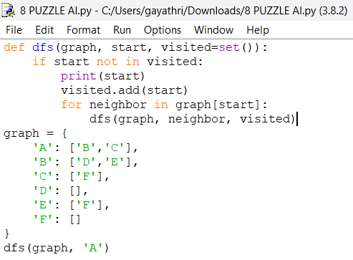

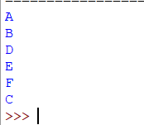

## **RESULT**

The program successfully performed **Depth-First Search (DFS)** on the given graph and printed the nodes in **depth-wise order** starting from node 'A'.